1. 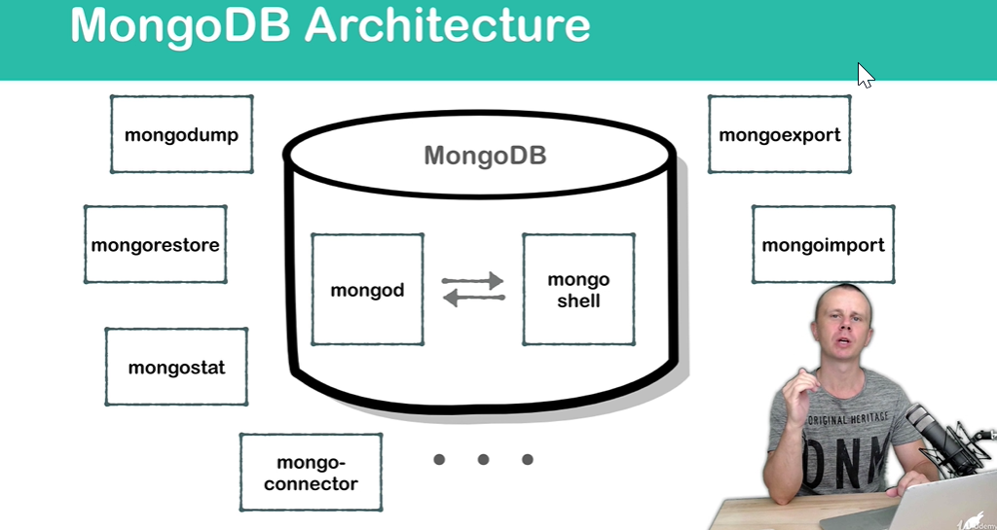
2. When we perform mongodb installation, we will get mongodb server and mongodb shell.
3. MongoDB server can be lunched using **mongod service**.
   1. **mongod**: Command to launch mongodb server.
4. MongoDB Shell can be lunched using mongo command.
   1. **mongo**: command to launch mongoDB shell.
   2. MongoDB shell is a separate utility. We use it to connect with MongoDB Server.
5. By default, we get other utilities too.
   1. **Mongodump**: Used to make dump from the mongodb.
   2. **Mongorestore**: Used to restore data from the dump.
   3. **MongoImport**: Used to import the parts of the database.
   4. **Mongoexport**: Used to export the parts of the database.
   5. **Mongostat**: Used to monitor in real time MongoDB performance.
6. We can install other utilities such as
   1. Mongo-connector:
7. Let’s brief:
8. MongoDB consists of
   1. MongoDB Server.
   2. MongoDB Shell.
   3. Other utilities.